**Lab02 - Basic Python**

Instructor: Byungyun Yang, TA:

In this lab, you will learn what is Python and learn simple grammar. You will then take what you've learned and create your own code. **Please answer all questions at the end of this exercise.**

**Learning objectives:** When you have completed this lab, you will be able to

1. Installing the Python libraries
2. Basic elements of Python
3. For roop
4. If : Conditional statements
5. Using modules and packages
6. Export your code to a ipynb file

**1.0 Installing the Python libraries**

**2.0 Basic of Python**

First of all, Python is a computer language that has a very similar grammar structure to English. In addition, Python is a very concise and strict language, and the code works only when the elements such as line alignment, quotation marks, and parentheses are correctly matched.

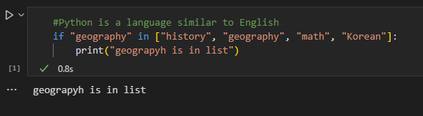

In the picture above, we can check two things, the first part where the code is written, and the second part is the result value printed below.

**2.1 Math**

Python can be used as a simple calculator.

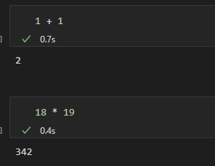

Using the math module, it is also possible to calculate complex equations such as functions, not quadratic operations.

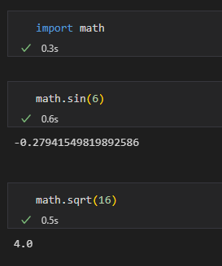

(sqrt = 제곱근)

**2.1 Print Functions**

The **Print()** function is a function that outputs the values in parentheses as text.

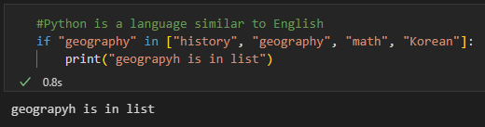

In addition, Python can create **Variable** to store and utilize values, and the names of variables can include **English (small, capitalized), Korean, special characters '_' (underbar), and numbers**. The method for assigning and storing variables is as follows.

**[variable_name = value]**

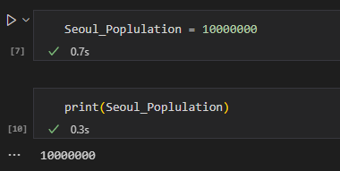

The code above is a code that sets the variable name to Seoul_Population and gives a value of 10000000, and the code below is a code that outputs the value of the variable.

**2.2 Data type**

There are four types of data in Python:

1. **Int** representing integer values (ex: 4)
2. **Float** representing decimal places (ex: 3.141592)
3. **Str** representing a string (ex: "Geography")
4. **Boolean** that distinguishes true/false

There is a method of distinguishing these data types by using the type() function.

In the picture below, since the value of Seoul_Population is an integer of 10000000, it can be seen that the data type appears as int.

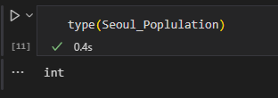

Some data types are compatible with each other, but some are not, so it is important to check the data types and convert them if necessary.

**In addition, unlike int and float types, which represent values in numbers, str type data must be represented using quotation marks such as "" and ‘’.**

**2.3 List and Index**

In Python, three data types are available: List, Tuple, and Dictionary, and in this lab, we will learn about List. As the name suggests, the List can store multiple values as a single List, which can basically be created using **square brackets []** as shown below, and can store multiple values regardless of the data type.

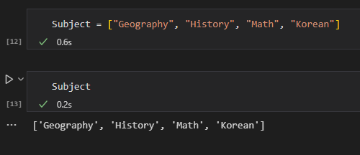

The above is a list of four values, Geography, History, Math, and Korean, which are stored in the list called Subject, and the code is printed out. In addition, if you check the data type through the type function, you can see that the data type is a list as shown below.

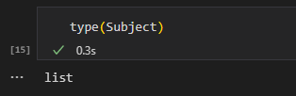

There is no limit to the number of values that can be stored in the List, and for this reason, if the number of values stored in the List increases, individual values of the List can be checked through the Index function.

Before we look at the Index function, we need to talk about how to count numbers in Python, which is basically a computer language, so when you count numbers, you don't start with 1 but start with 0. That is, the order of the first values of the List is 0 rather than 1. Let's think about how to count and use the Index function..

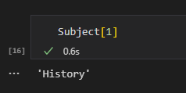

In Subject, the list made above, you can see that History is 1 instead of 2, and Geography, the first order, is 0 instead of 1.

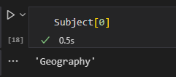

**3.1 For (Repeat)**

Next, For is a function used to represent repetition statements.

When outputting the values of the list called Subject created above one by one, outputting them one by one using the Print function takes a long time and is inefficient because the code is not clean. Therefore, we will simplify the code through For functions and express it efficiently.

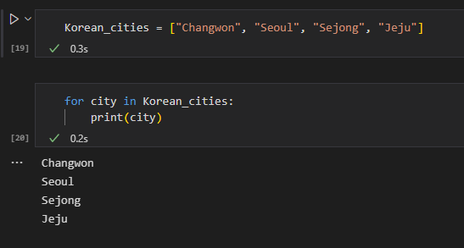

The for function above is represented by the code [for city in Korean_cities: print(city)], which is the most basic way to put the desired variable name in the city position and the list name in the Korean_cities position, add ":"(colon), change the line to make four spaces, and print the output.

**4.1 If (Conditional Statement)**

The conditional statement is a function that allows different result values to be output depending on whether the set conditions are satisfied or not. When creating this condition, if is used, and the default format is as follows..

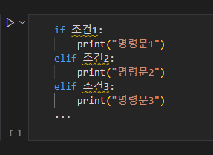

**When setting the first condition, if is used, and elif is used for the second or more conditions. Finally, else is used when all those conditions are not satisfied. In addition, just like for, the end of the if conditional statement should be:(colon), and change the line to make four spaces, and print the output**

Based on this basic form, we will make a conditional statement using the following conditions.

**조건 1 :지도학 TO = 존재, 명령문1 : 지도학 강의를 수강한다.**

**조건 2: 지도학 TO = 없음, 명령문2 : 교양 강의를 수강한다.**

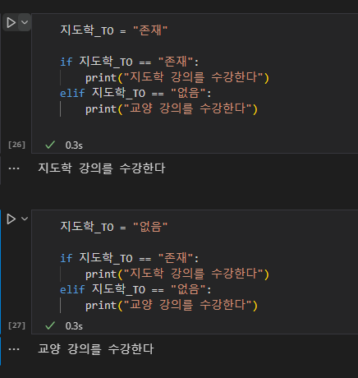

If you create a conditional statement using the conditions presented, you can write these codes.

So far, You have studied the basic grammar of Python. However, we only studied the most important parts of basic grammar, so we recommend studying basics Python more through YouTube and Github to study practice smoothly in the future.

**5.1 Using modules and packages**

Since the main purpose of the future exercises is to analyze geographic data using Python rather than basic Python, we will mainly use geographic data-related packages and modules, so we will find out how to use them and wrap up the practice.

First of all, a module refers to a file containing various codes written to be useful for executing a specific task, and representatively, there is a math module used above.

Next, the package is a set of modules. Above, the module is said to be a file containing several similar codes, but the package is a collection of similar modules.

The packages (modules) that we will mainly use in the future are typically "pandas", "numpy", and "matplotlib", and we will look at what they do and how they are used in Python.

First of all, Pandas is a package for data analysis that is used for tasks such as analyzing and merging data from various files such as txt, Excel, and JSON, and we will use it through a package called "Geopandas" that can analyze the functions of existing Pandas as well as geometric data.

Next, Numpy is a package mainly used to process matrix or array data, and we will use this package mainly for numerical computations.

Finally, Matplotlib is mainly used to visualize data, and we will use data analyzed using pandas to visualize it as graphs, histograms, etc.

The method of using these packages (modules) in Python can be used using import.

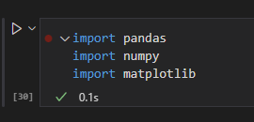

**6.0 Export your code to a ipynb file**

**Assignment**: There are two submissions to get a full credit. First, in a **Word Document (Lastname_Lab01report.docx)**, answer these questions. Second you must submit the files you have worked on as an ipynb file with your Word document (or Google document). The practice file is worth five points.

과제 제출은 Google doc 또는 MS word로 작성해주시기 바랍니다. 답변은 한글 또는 영어로 작성해주세요. 기술은 **완벽한 2~3개의 문장(Sentences)**으로 쓰고 **반드시 주요 Keywords**가 정확한 표현으로 들어가야 하며, **한글 문법이나 철자에 오류**가 있으면 안됨. (임용 채점 Style)